**TASK 01:**

**OUTPUT**:

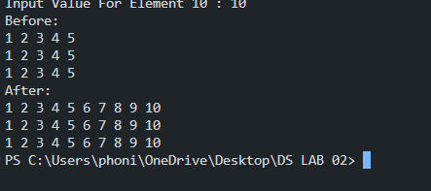

**TASK** **02:**

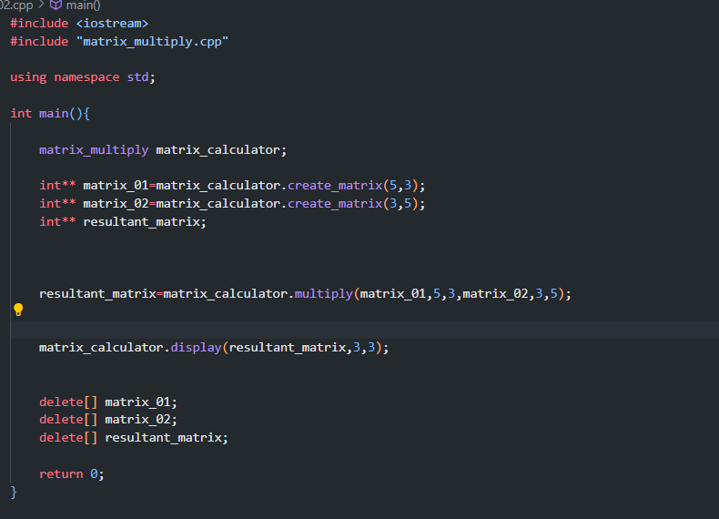

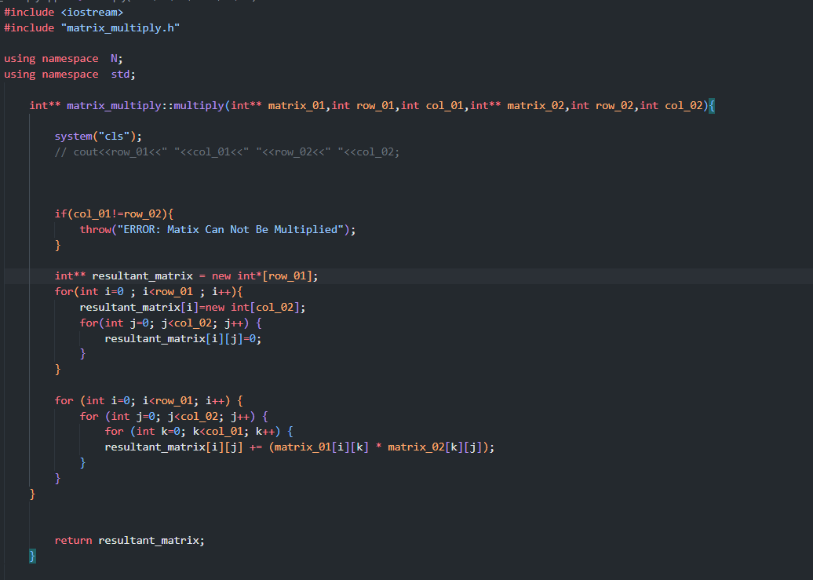

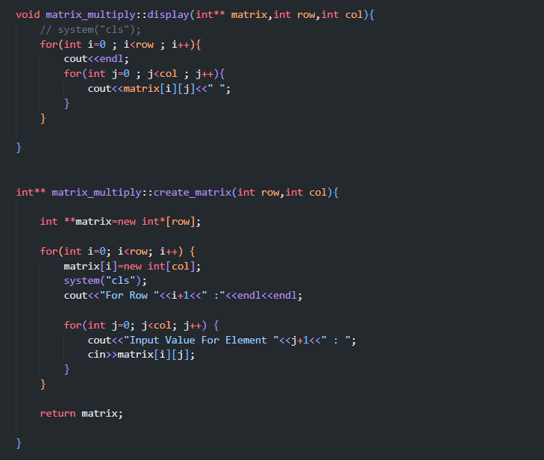

**OUTPUT:**

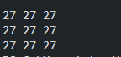

**TASK 03:**

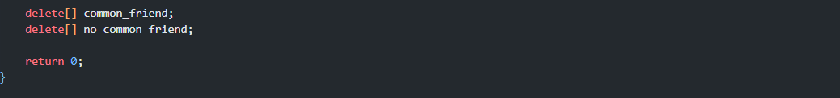

**OUTPUT:  
**

**TASK 04:**

**OUTPUT:**

**TASK 05:**

**OUTPUT:**

